Project Design Phase-II
Technology Stack (Architecture & Stack)
Date | 02 February 2026
Team ID | LTVIP2026TMIDS34601
Project Name | TransLingua
Maximum Marks | 4 Marks

Technical Architecture:
The Deliverable shall include the architectural diagram as below and the information as per the table1 & table 2 Example: Order processing during pandemics for offline mode
Reference: https://developer.ibm.com/patterns/ai-powered-backend-system-for-order-processing-during-pandemics/

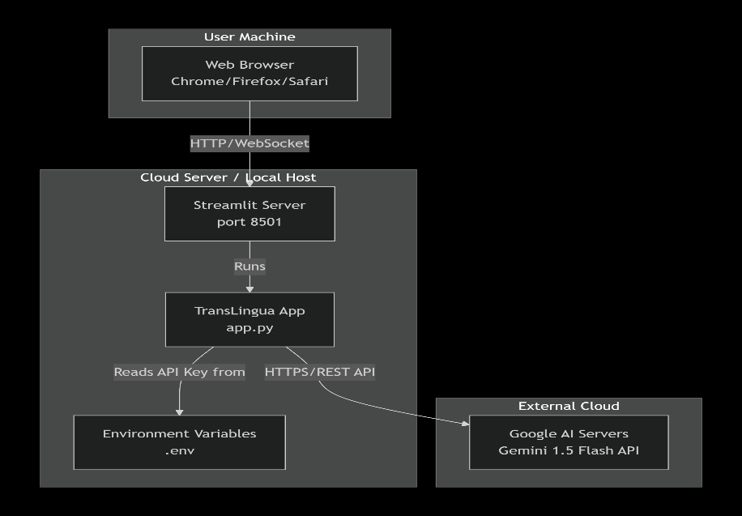
Table-1 : Components & Technologies:
S.No | Component | Description | Technology
1. | User Interface | Web-based UI where users input text, select languages, and view translations | Streamlit (Python), HTML, CSS (Cyberpunk Theme)

2. | Application Logic-Translation | Core translation processing that sends prompts to AI and returns translated text | Python, Google Generative AI SDK (google-generativeai)
3. | Application Logic-Auto Detection | Intelligent source language identification using AI prompts | Python, Google Gemini AI (Prompt Engineering)
4. | Application Logic-CSS Rendering | Loads and applies futuristic cyberpunk styling to the web interface | Python (file I/O), CSS3 (Animations, Glassmorphism)
5. | External API | Google Gemini AI API for both language detection and text translation | Google Gemini 2.0 Flash (gemini-2.0-flash)
6. | Environment Configuration | Secure management of API keys and environment variables | python-dotenv, .env file
7. | Infrastructure (Local) | Application runs on local machine with Streamlit built-in development server | Python 3.8+, Streamlit Server, localhost:8501

Table-2: Application Characteristics:
S.No | Characteristics | Description | Technology
1. | Open-Source Frameworks | Streamlit for web interface, Google Generative AI SDK for AI integration | Streamlit (Apache 2.0), google-generativeai (Python SDK)
2. | Security Implementations | API keys stored in .env files, excluded from version control via .gitignore. No user data collection or persistent storage. Direct HTTPS API communication. | python-dotenv, .gitignore, HTTPS/TLS
3. | Scalable Architecture | Modular single-file architecture with separated CSS. Translation and detection functions are independent modules that can be extended. Future-ready for REST API endpoint creation. | Python Modular Design, External CSS
4. | Availability | Streamlit built-in server handles multiple concurrent sessions. Google Gemini API provides 99.9% uptime SLA. | Streamlit Server, Google Cloud Infrastructure
5. | Performance | Average translation response under 3 seconds. Character limit of 3000 prevents API overload. Real-time progress feedback keeps user engaged during processing. | Streamlit Progress Bar, Gemini Flash Model (optimized for speed)

References:
https://c4model.com/
https://developer.ibm.com/patterns/online-order-processing-system-during-pandemic/
https://www.ibm.com/cloud/architecture
https://aws.amazon.com/architecture
https://medium.com/the-internal-startup/how-to-draw-useful-technical-architecture-diagrams-2d20c9fda90d

